<!DOCTYPE html>

<html lang="en">

<head>

<meta charset="UTF-8">

<meta name="viewport" content="width=device-width, initial-scale=1.0">

<title>Document</title>

</head>

<body>

<!DOCTYPE html>

<html>

<head>

<title>Poster Presentation</title>

<style>

table {

border-collapse: collapse;

width: 100%;

}

th, td {

border: 1px solid black;

padding: 10px;

text-align: left;

}

th {

background-color: #f2f2f2;

}

</style>

</head>

<body>

<h1>Poster Presentation: The Importance of Bees in Ecosystems</h1>

<table>

<tr>

<th colspan="2">Introduction</th>

</tr>

<tr>

<td colspan="2">Bees play a crucial role in pollinating plants and maintaining biodiversity in ecosystems.</td>

</tr>

<tr>

<th>Benefits of Bees</th>

<th>Challenges</th>

</tr>

<tr>

<td>1. Pollination of crops</td>

<td>1. Colony collapse disorder</td>

</tr>

<tr>

<td>2. Biodiversity preservation</td>

<td>2. Pesticide exposure</td>

</tr>

<tr>

<td>3. Honey production</td>

<td>3. Habitat loss</td>

</tr>

<tr>

<th colspan="2">Research Findings</th>

</tr>

<tr>

<td colspan="2">Our research shows that bees are declining due to a combination of factors including habitat loss and pesticide exposure.</td>

</tr>

<tr>

<th>Conclusion</th>

<th>References</th>

</tr>

<tr>

<td>Conservation efforts are essential to ensure the survival of bees and the ecosystems they support.</td>

<td>1. Smith, J. (2019). The Role of Bees in Ecosystems. Environmental Studies Journal, 25(2), 45-62.</td>

</tr>

</table>

</body>

</html>

</body>

</html>

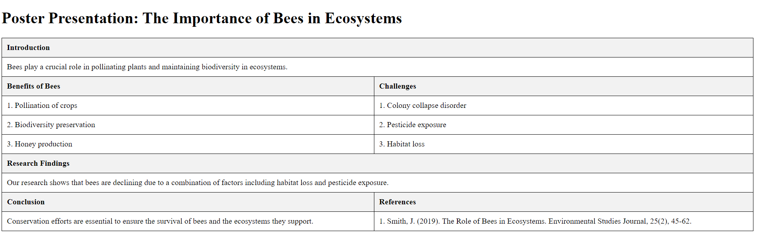

<!DOCTYPE html>

<html lang="en">

<head>

<meta charset="UTF-8">

<meta name="viewport" content="width=device-width, initial-scale=1.0">

<title>Document</title>

<style>

table{

border-collapse: collapse;

width: 30%;

text-align: center;

}

tr td{border:1px solid gray;}

</style>

</head>

<body>

<table>

<tr>

<td colspan="2">A</td>

<td colspan="5">B</td>

</tr>

<tr>

<td>C</td>

<td>D</td>

<td>E</td>

<td>F</td>

<td>G</td>

<td>H</td>

<td rowspan="3">J</td>

</tr>

<tr>

<td rowspan="2">K</td>

<td>M</td>

<td colspan="2">N</td>

<td colspan="2" style="text-align: left;">I</td>

</tr>

<tr>

<td>L</td>

<td>P</td>

<td>O</td>

<td>I</td>

<td>H</td>

</tr>

</table>

</body>

</html>

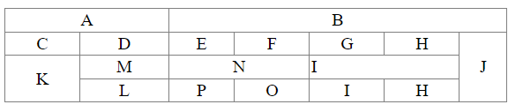

<HTML>

<HEAD>

<TITLE>A Complete HTML Frameset Exmaple | TutorialsClass.com</TITLE>

</HEAD>

<frameset cols="30%, 70%" bordercolor="blue" noresize="noresize">

<frame name="first-frame" src="page1.html"></frame>

<frameset rows="300, 400" bordercolor="red">

<frame name="second-frame" src="page2.html">

<frame name="third-frame" src="page3.html"></frame>

</frameset>

<noframes>

<p> This document contains frames content. You browser does not support it. </p>

</noframes>

</frameset>

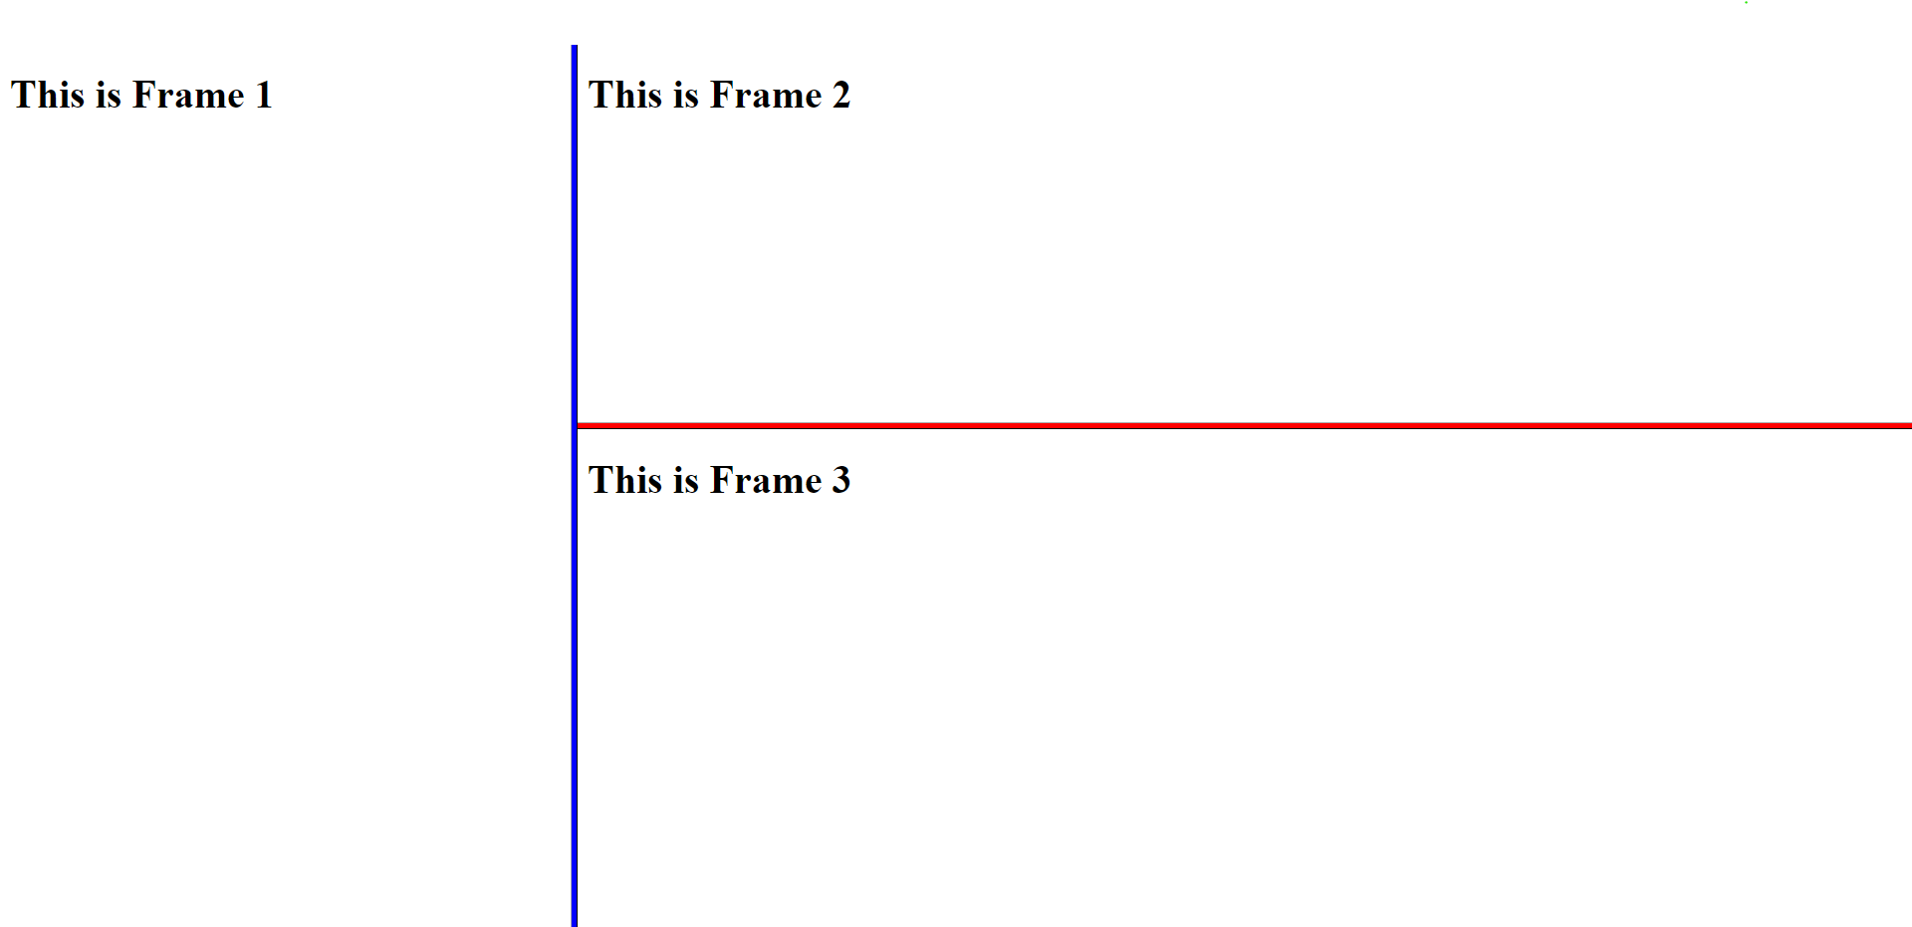 </HTML>

<!DOCTYPE html>

<html lang="en">

<head>

<meta charset="UTF-8">

<meta name="viewport" content="width=device-width, initial-scale=1.0">

<title>Registration Form</title>

<style>

body {

margin: 0;

padding: 0;

background: url('dancing_boat_image.jpg') center/cover no-repeat fixed;

font-family: Arial, sans-serif;

display: flex;

justify-content: center;

align-items: center;

min-height: 100vh;

}

form {

background: rgba(255, 255, 255, 0.9);

padding: 20px;

border-radius: 10px;

box-shadow: 0 0 10px rgba(0, 0, 0, 0.3);

width: 300px;

}

label {

display: block;

margin-bottom: 5px;

font-weight: bold;

}

input {

width: 100%;

padding: 8px;

margin-bottom: 10px;

border: 1px solid #ccc;

border-radius: 5px;

}

input[type="submit"] {

background-color: #4CAF50;

color: white;

padding: 10px 15px;

border: none;

border-radius: 5px;

cursor: pointer;

}

input[type="submit"]:hover {

background-color: #45a049;

}

input:invalid {

border-color: #E57373;

}

input:valid {

border-color: #81C784;

}

</style>

</head>

<body>

<form action="#" method="post" >

<label for="username">Username:</label>

<input type="text" id="username" name="username" required pattern="[a-zA-Z0-9_-]{3,20}">

<small><!--3-20 characters, letters, numbers, underscores, and hyphens only.--></small>

<label for="email">Email:</label>

<input type="email" id="email" pattern=".+@(gmail\.com|yahoo\.com|outlook\.com)" size="30" name="email" required>

<label for="password">Password:</label>

<input type="password" id="password" name="password" required minlength="6">

<small><!--Minimum length: 6 characters.--></small>

<label for="confirm_password">Confirm Password:</label>

<input type="password" id="confirm_password" name="confirm_password" required minlength="6" pattern="(?=.*\d)(?=.*[a-z])(?=.*[A-Z]).{6,}">&nbsp;&nbsp;

<small style="color: grey">At least one lowercase letter, one uppercase letter, one digit, and minimum length of 6 characters.</small>

<input type="submit" value="Register">

</form>

</body>

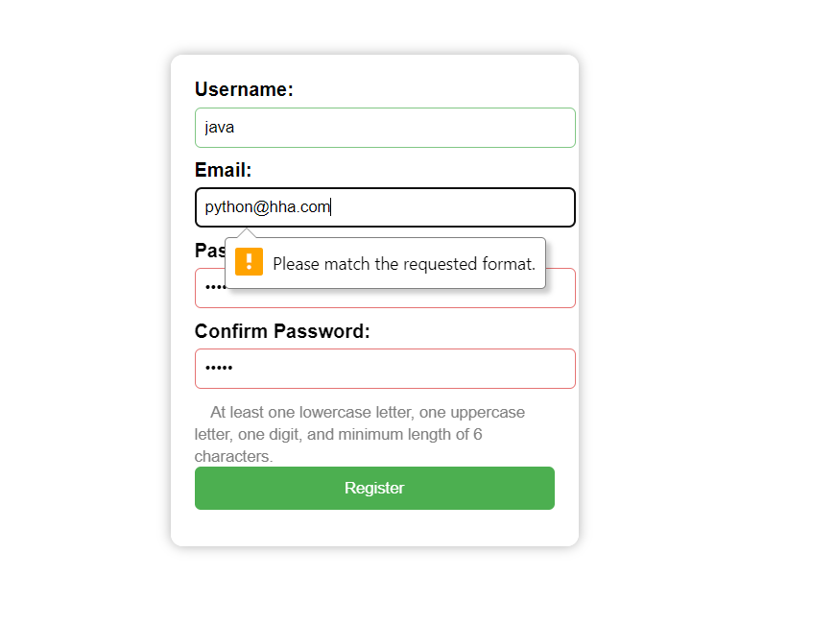</html>